**Coupling:**

The degree of dependency between the components is called coupling. If dependency is more then it is tightly coupling otherwise it is loosely coupling.



The above components are said to be tightly coupled with each other because dependency between the components is more. Tightly coupling is not a good programming practice because it has several disadvantages.

1. Without affecting any component we can’t modify any component and hence enhancement will become difficult.
2. It supresses reusability.
3. It reduces maintainability of the application.

Hence we have to maintain dependency between the components as less as possible i.e. loosely coupling is a good programming practice.

**Cohesion:**

For every component a clear well defined functionality is defined then that component is said to be follow high cohesion.

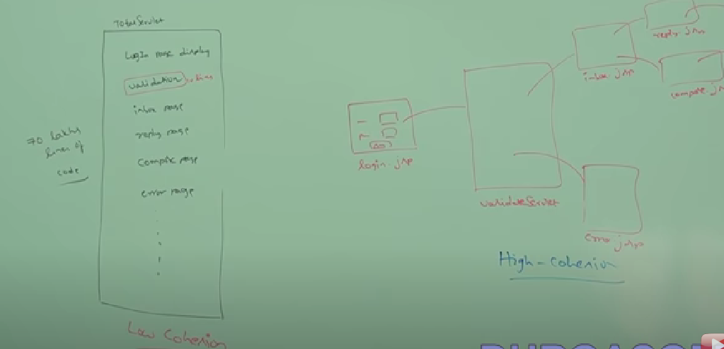

High cohesion is a good programming practice. It has several advantages.

1. Without affecting any component we can modify component any component hence enhancement will become easy.
2. It promotes reusability of the code(wherever validation logic is required we can reuse the same validate servlet without rewriting).
3. Improves maintainability of the program.

**Object type-casting:**

We can use parent reference to hold child object. EX: Object o = new String(“durga”);

We can use interface reference to hold implemented class object.

EX: Runnable r = new Thread();

